The Korean Diaspora: Interpreting Graphs and Charts
Below are three charts and graphs that describe how Koreans immigrated throughout the world. Use the charts to answer the questions.
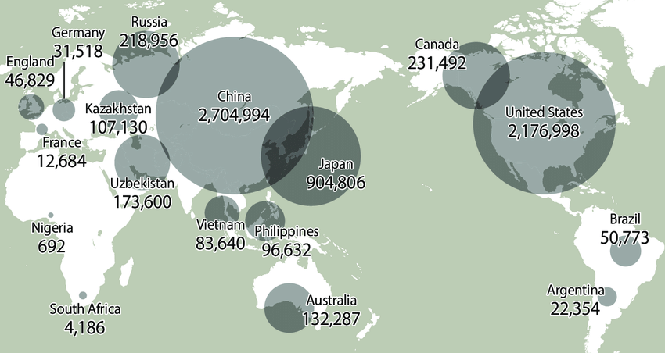  Koreans Across the Globe, 2011 (Source: "World's widest diaspora born over 100 years ago." Korea Joongang Daily, October 2, 2013.) | - Which two countries have the most Korean immigrants (as of 2011)?
 | - How many Korean immigrants lived in Canada in 2011?
 | - What country has over 170,000 Korean immigrants (as of 2011)?
 | - Make a comparison: In 2011 there were MORE/LESS Korean immigrants in WHERE than WHERE.
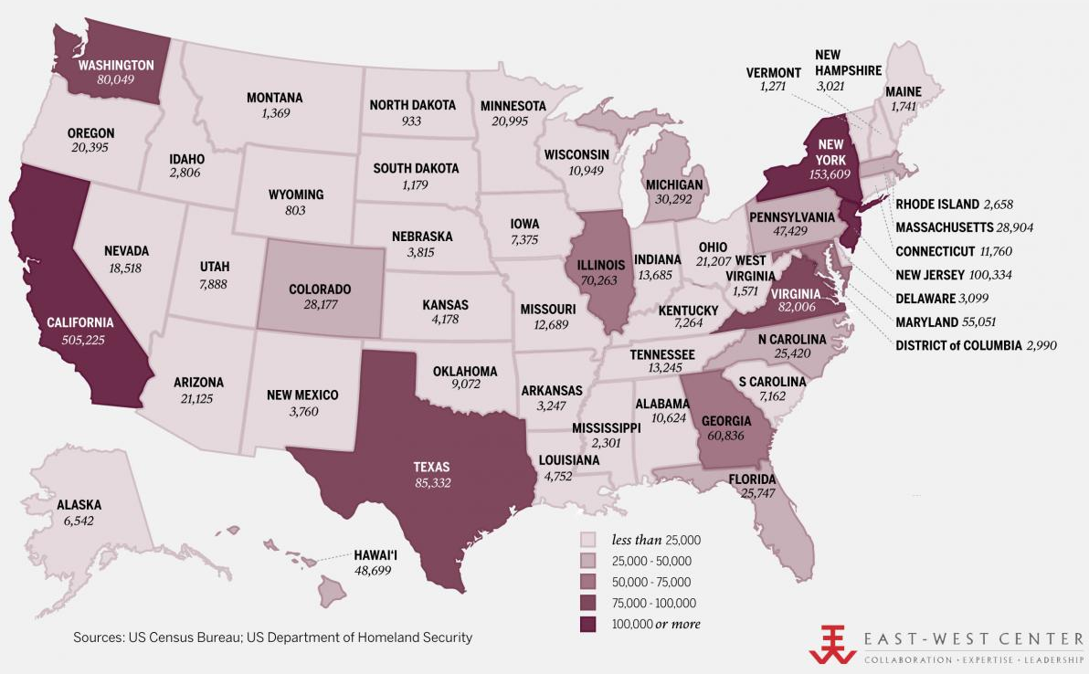  Korean American Population by State, 2010 (Source: US Census Bureau, US Department of Homeland Security.) | - Which five states have the most Korean Americans?
 | - How many Korean Americans lived in California in 2010?
 | - What is a state with one of the smallest Korean American populations?
 | - What is a small state with a high number of Korean Americans?
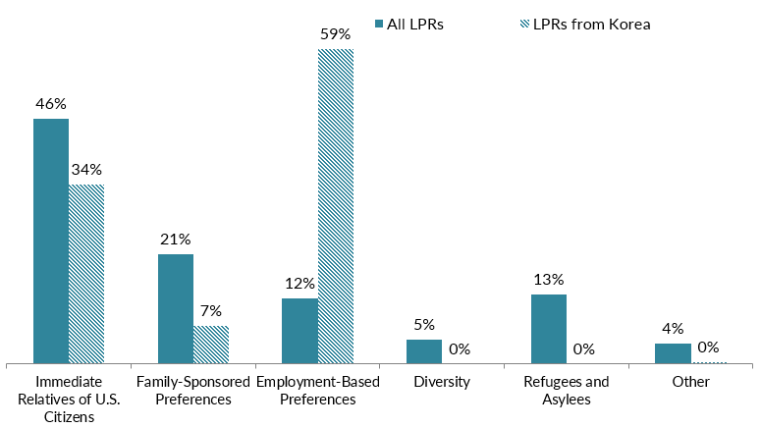  Immigration Pathways of Korean Americans and All Immigrants in the U.S., 2017 (Source: MPI tabulation of data from Department of Homeland Security (DHS), 2017 Yearbook of Immigration Statistics (Washington, DC: DHS Office of Immigration Statistics, 2018) | - In 2017, more than 19,200 Korean immigrants became lawful permanent residents (LPRs). What percent obtained this status through employer sponsorship?
 | - What percent of All Immigrants were sponsored by immediate relatives of U.S. citizens?
 | - What percent of Korean immigrants were beneficiaries of the Diversity Visa Lottery or were refugees?
 | - Make a comparison by completing this sentence: In 2017, MORE/LESS Korean Americans obtained legal status through WHICH PATHWAY than all U.S. Immigrants.

