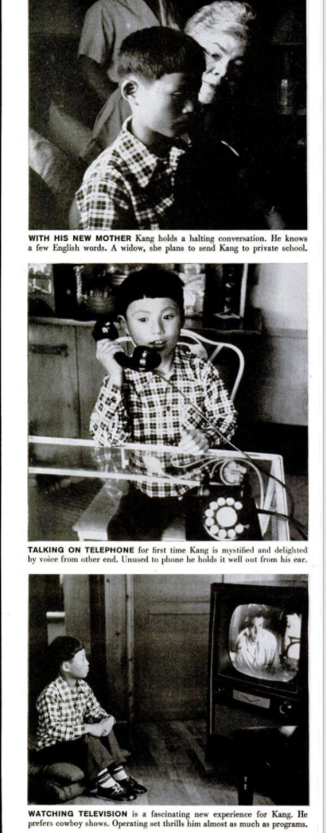
“A Famous Orphan Finds a Happy Home”
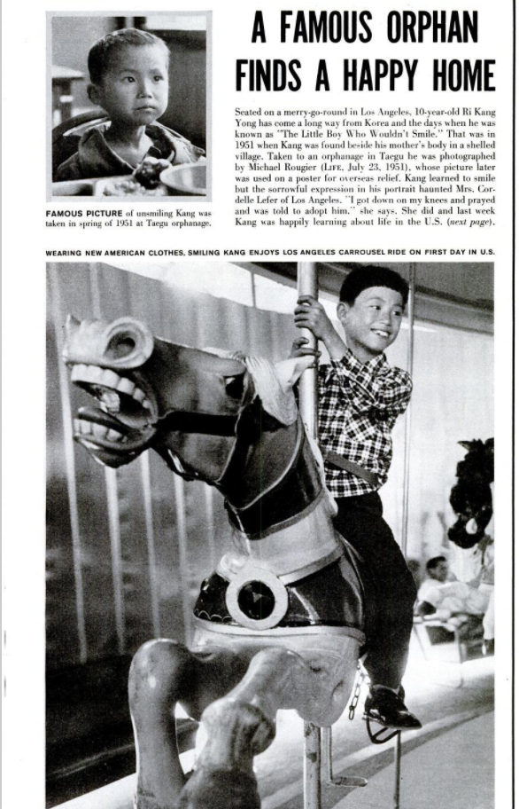
Life Magazine, May 14, 1956, pp. 129-130.

Seated on a merry-go-round in Los Angeles, 10-year-old Ri Kang Yong has come a long way from Korea and the days when he was known as “The Little Boy Who Wouldn’t Smile.” That was in 1951 when Kang was found beside his mother’s body in a shelled village. Taken to an orphanage in Taegu he was photographed by Michael Rougier (Life, July 23, 1951), whose picture was later used in a poster for overseas relief, Kang later learned to smile but the sorrowful expression in his portrait haunted Mrs. Cordelle Lefer of Los Angeles. “I got down on my knees and prayed and was told to adopt him,” she says. She did and last week Kang was happily learning about life in the U.S. (next page).

- FAMOUS PICTURE of unsmiling Kang was taken in Spring of 1951 at Taegu orphanage.
- WEARING NEW AMERICAN CLOTHES, SMILING KANG ENJOYS LA CARROUSEL RIDE ON FIRST DAY IN US.
- WITH HIS NEW MOTHER, Kang holds a halting conversation. He knows a few English words. A widow, she plans to send Kang to private school.
- TALKING ON TELEPHONE for first time, Kang is mystified and delighted by voice on other end. Unused to phone, he holds it well out from his ear.
- WATCHING TELEVISION is a fascinating new experience for Kang. He prefers Cowboy shows. Operating the set thrills him about as much as programs.
“A Famous Orphan Finds a Happy Home”
QUESTIONS TO ANSWER
- What is this article about?
- What is the tone of the article (i.e. happy, sad, optimistic, pessimistic, etc.)?
- What is the story being told by the photographs? Select one of these photographs and take a second look. Describe what is in the photograph and how it demonstrates is Ri Kang Yong adapting to the United States. What specific parts of the photograph support your answer?
- How does the article as a whole, text and photos combined, describe Korea? Describe America? What is the overarching message about these two countries?
- How does this article promote or oppose Korean adoptions? Provide evidence from the article for your answer.
- What questions and concerns do you have after reading this article?

