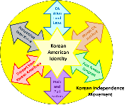
Activity 4.2: How did the Korean Independence Movement shape and become shaped by the formation of the Korean American identity in the United States?
Event | How Event Shaped Korean American Identity | How Event Shaped Korean Independence Movement
Push/Pull Factors
CA Alien Land Acts
Hemet, CA Incident
First Korean Congress
Perspectives from Korea
Support from Korean Americans

